011 TypeScript - switch statements

TypeScript Kata List – Blog Page

[TypeScript Kata List on GitHub](https://github.com/robertdunaway/katas-typescript)

# Duration

10 minutes

# Brief

Using switch statements

### For More Information

BING/GOOGLE: “TypeScript switch”

# Instructions

Get tutorial folder or the entire katas-typescript repo.

Open the [before/*.sln] file and execute the kata.

Feel free to execute this kata multiple times because repetition creates motor memory.

# Github

* Before (start kata with this)
  + https://github.com/robertdunaway/katas-typescript/tree/master/011%20TypeScript%20-%20switch%20statements/before
* After
  + https://github.com/robertdunaway/katas-typescript/tree/master/011%20TypeScript%20-%20switch%20statements/after

# Kata

Create a variable and then compare it in a switch statement then output the results to the console.

[highlight below for one possible answer]

var result: string = 'dog';

switch (result) {

case 'cat':

{

console.log('a cat was chosen');

}

case 'dog':

{

console.log('a dog was chosen');

}

}

Create another switch statement but add a “default”.

[highlight below for one possible answer]

switch (result) {

case 'cat': {

console.log('a cat was chosen');

}

case 'bird': {

console.log('a bird was chosen');

}

default: {

console.log('the default was used.');

}

}

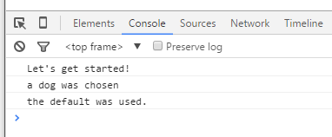

# Next

Take a few minutes and imagine more examples.